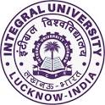

**Department of Chemistry, Integral University, Lucknow**

**Poster Making Competition on**

**“World Science Day for Peace and Development”**

**Date: 10th November, 2022**

The Department of Chemistry, Integral University, Lucknow on 10th November, 2022 organized a Poster Making Competition based on the theme “World Science Day For Peace and Development” to commemorate the World Science Day which was coordinated by Dr. Tahmeena Khan, Assistant Professor, Department of Chemistry and Mohd. Arsh Khan, student coordinator from B.Sc. (Industrial chemistry) in NLT 5 at 11:00 am onwards. Students from different streams showcased their views by creative and eye-catchy posters depicting the various applications of Science for peace and sustainable development. The objective of the activity also covered the **Sustainable Development Goal (SDG) 16** which talks about promoting peaceful and inclusive peaceful and inclusive societies providing access to justice for all and building effective, accountable and inclusive institutions at all levels. The participants presented interesting scientific ideas for peace-building through eye catchy posters. The competition was judged by Dr. Minaxi B. Lohani, Associate Professor, Department of Chemistry. And Dr. Qazi Inamur Rahman, Assistant Professor, Department of Chemistry. Each student was allotted 3-5 minutes to explain their poster to the judges. The winners of the competition were as follows:

1st- Ms. Mehvish Ansari (B.Com. (H) IInd year)

IInd- Ms. Shumaila Suhail (M.Sc. Chemistry)

IIIrd- Ms. Mariya (M.Sc. Microbiology)

**Glimpses of the event**

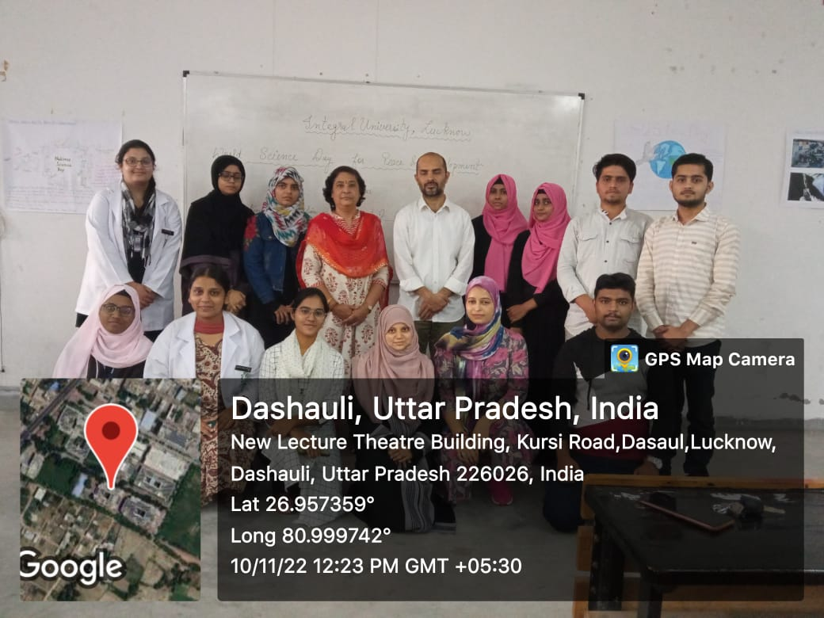 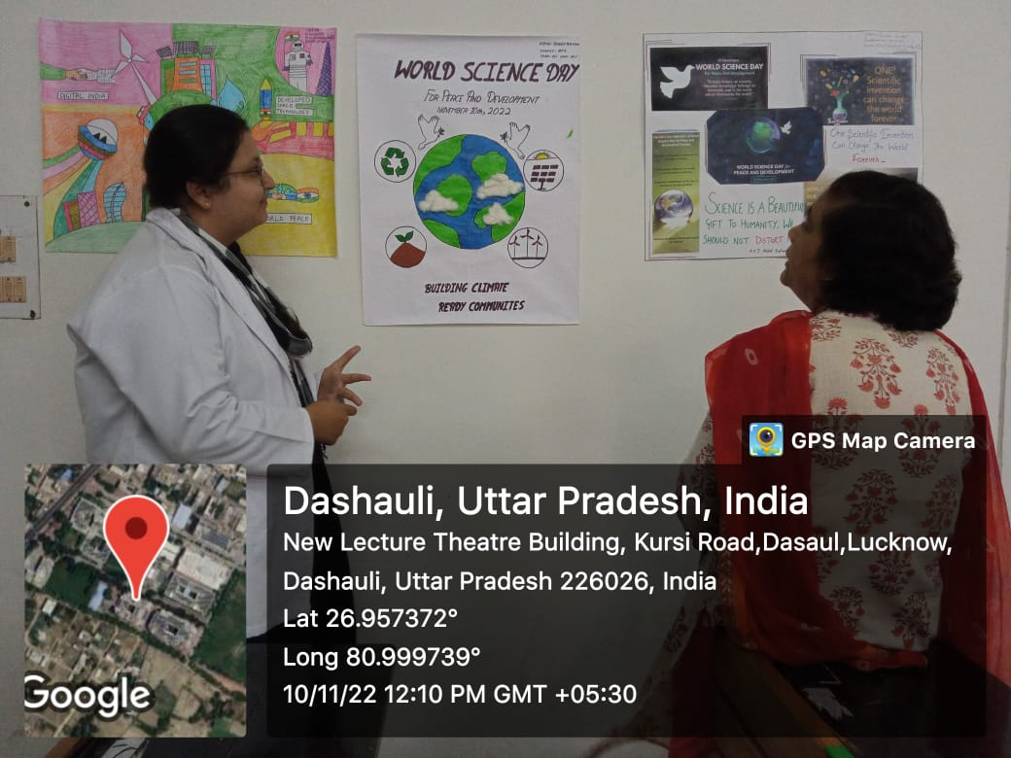

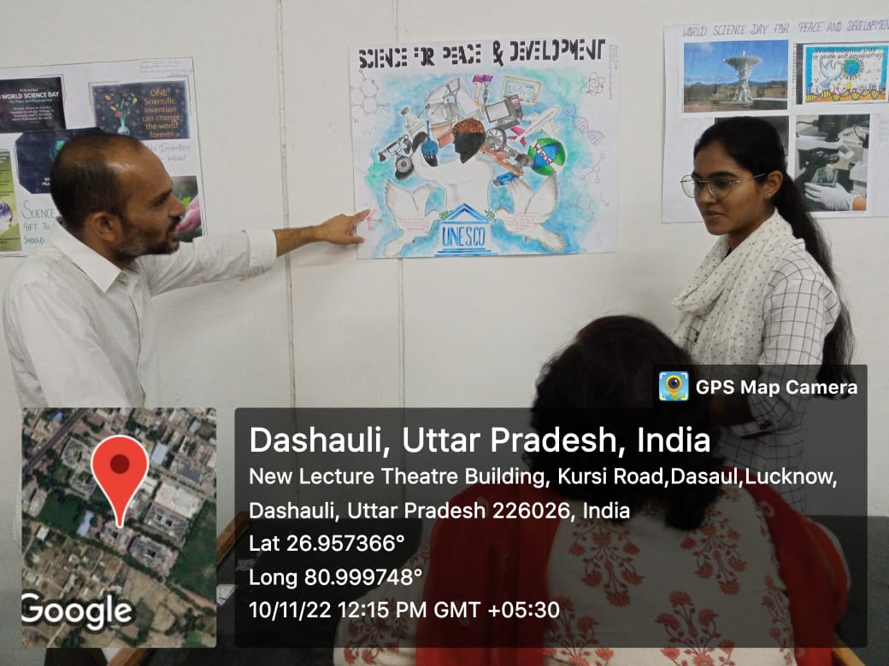 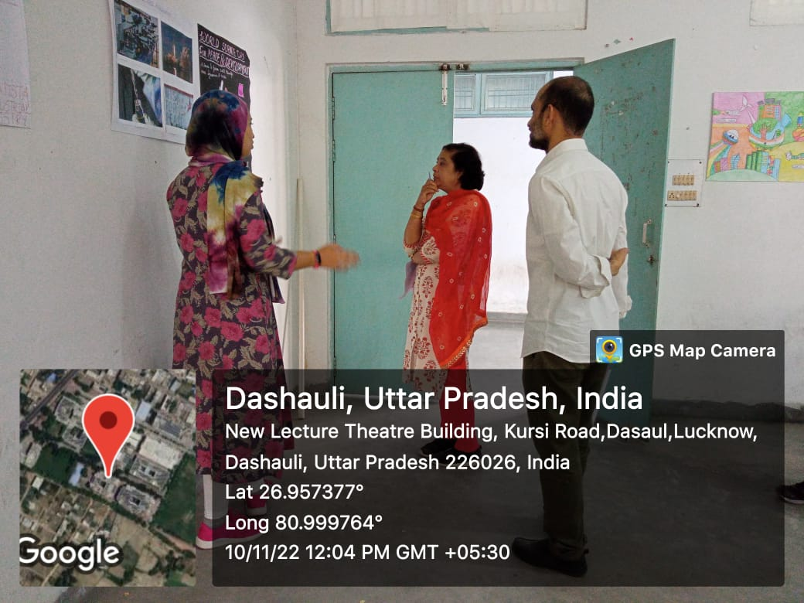

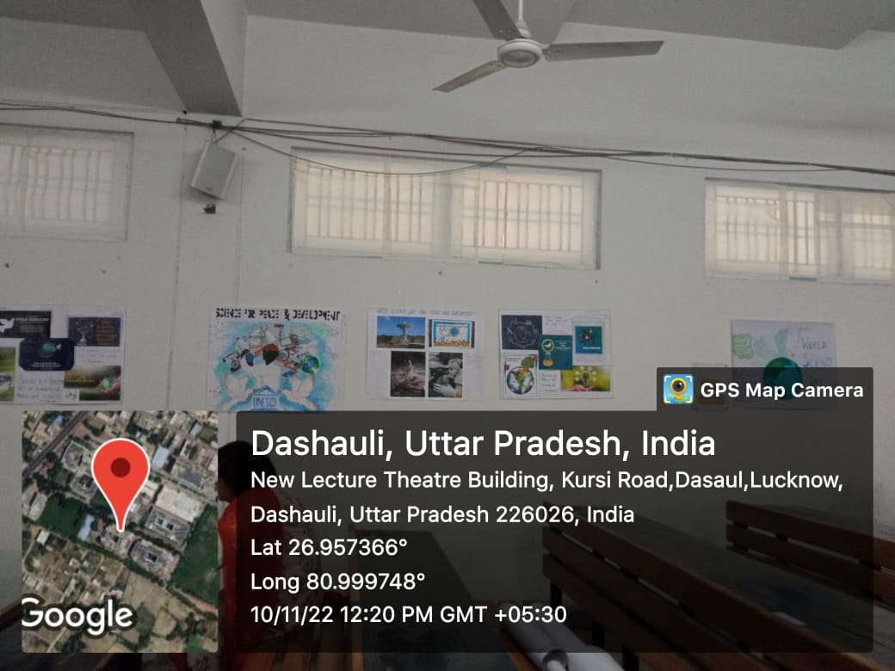

Submitted by

Dr. Tahmeena Khan